**Question 36 (11 marks)**

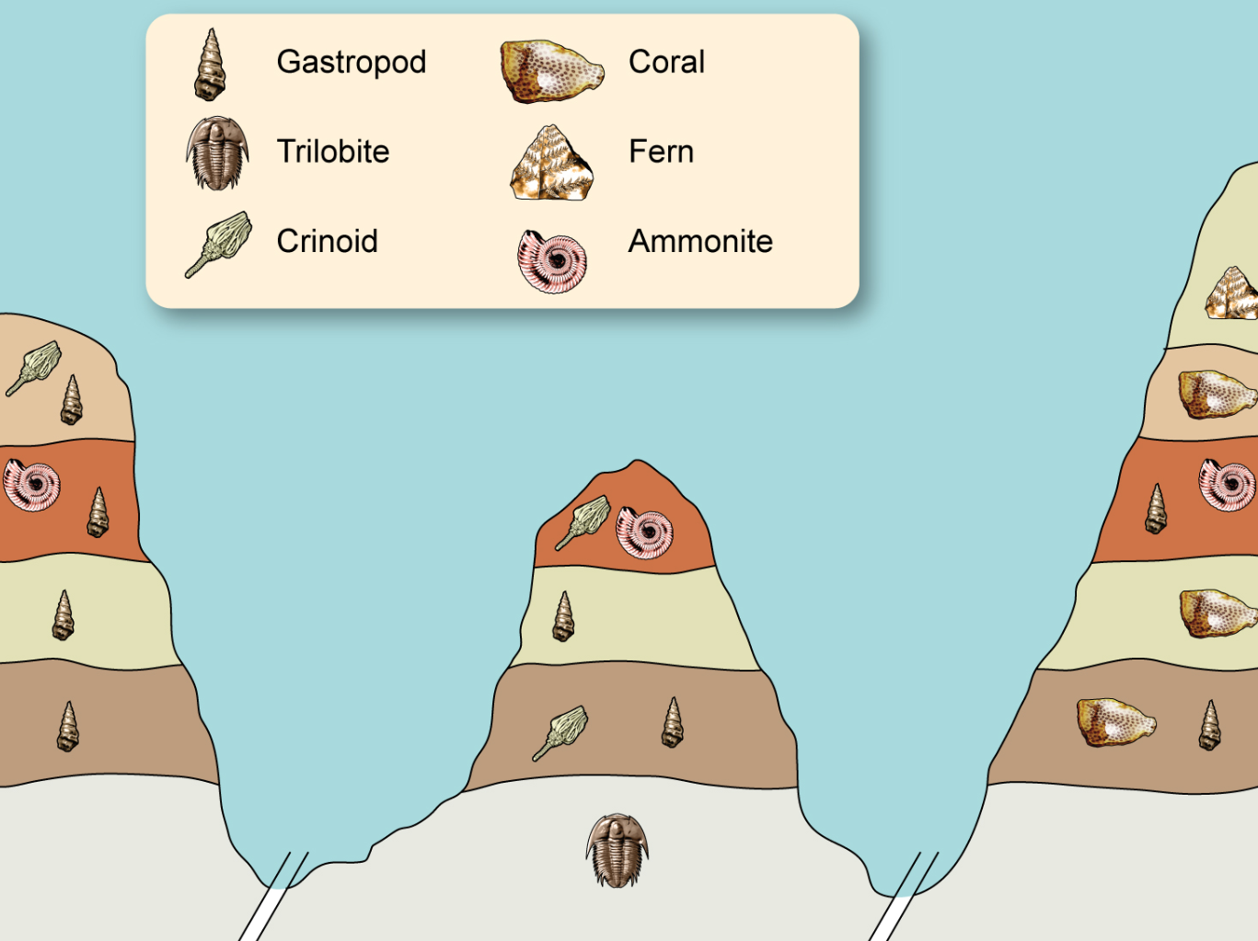

1. Which is the most recently evolved fossil out of the ammonite and crinoid? Provide a reason for your choice. (2 marks)

_________________________________________________________________________________________________________________________________________________________________________________________________________

1. Explain whether the gastropod would be a suitable organism to be used as an index fossil. (2 marks)

_________________________________________________________________________________________________________________________________________________________________________________________________________

1. What is absolute dating? Name **two** different types of absolute dating and for each identify the object that is tested and the age range for the object. (7 marks)

...................................................................................................................................................

……………………………………………………………………………………………………………

……………………………………………………………………………………………………………

...................................................................................................................................................

……………………………………………………………………………………………………………

……………………………………………………………………………………………………………

...................................................................................................................................................

……………………………………………………………………………………………………………

……………………………………………………………………………………………………………

...................................................................................................................................................

……………………………………………………………………………………………………………

……………………………………………………………………………………………………………

...................................................................................................................................................

……………………………………………………………………………………………………………

……………………………………………………………………………………………………………